**Introduction**

**I am Maqueen**

Hello, my name is Maqueen, is a graphical programming robot for STEM education, which inherits playability and simple operation of micro:bit. The Mini-body, interesting features and plug-and-play allow children to quickly learn graphic programming in entertaining, nurturing children's interest in science and logical thinking.

**What are the features of Maqueen?**

* Support for Makecode, will support Scratch and python later.
* Small size, flexible movement.
* All-metal miniature gear motor, good quality, strong driving force.
* Line patrol, ambient light, LED lights, ultrasonic interface, buzzer, I2C interface, mechanical expansion screw hole, etc. ... full-featured, highly expandable.
* Exclusive customized POM bearing wheel, flexible and reliable, strong obstacle crossing ability.
* Easy to install, easy to use.

**Function Diagram**

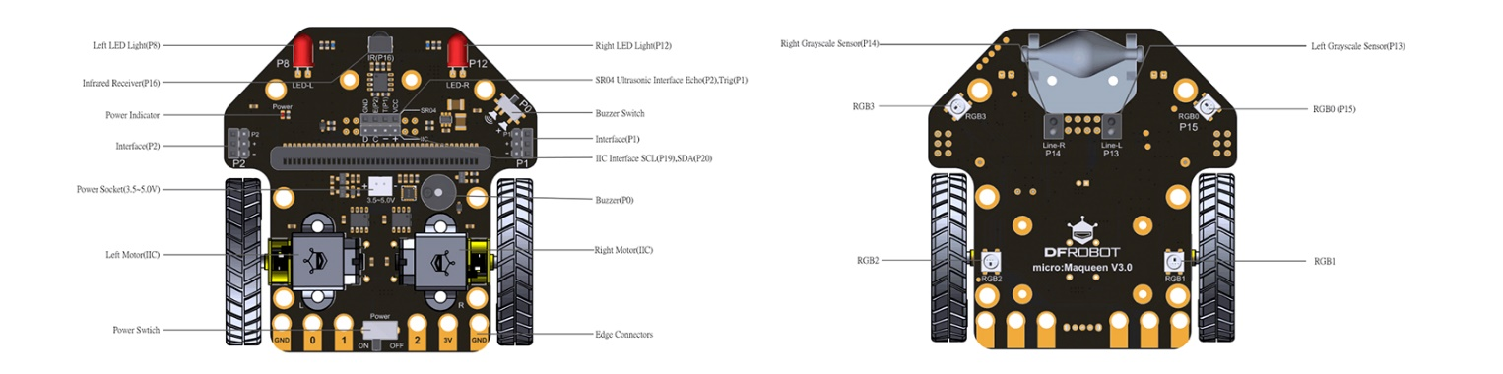

**Specification**

* Supply Voltage: 3.5V~5V DC ( Three AAA batteries or 3.6V~3.7V lithium battery )
* Infrared Grayscale Sensor(High-low level) x 2
* Buzzer x 1
* Infrared Receiver (NEC decoder) x 1
* LED Lights (High-low level control) x 2
* RGB Ambient Light (16 million colors) x 4
* SR04, SR04P Ultrasonic Interface(5V) x 1
* IIC Interface (3.3V) x 1
* Gravity Extension Interfaces (P1, P2) x 2
* N20 All-metal Gear Motor x 2
* Motor Reduction Ratio: 1:150
* Maximum Rotate Speed: 133 rpm
* Motor Drive Mode: PWM motor drive
* Bracket and Protective Cover Extension M3 Screw Hole x 6
* Programming Method: Makecode graphical programming, Mind graphical programming (based on Scratch 3.0)
* Dimension: 81mm x 85 mm x 44mm/3.19 x 3.35 x 1.73in
* Weight: 75.55g

**Product Configuration List**

* Car Body x 1 (Motors and bearing wheel have been assembled before leaving factory)
* Wheel x 2
* Three AAA batteries Box x 1
* Double Sided Adhesive Tape x 1

**Product Installation**

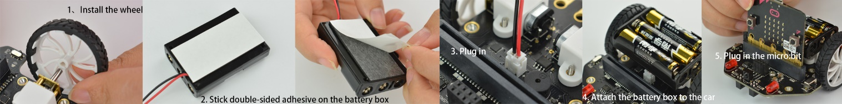

**Import the Makecode Graphical Library**

1. Click the link: [**makecode.microbit.org**](https://makecode.microbit.org/), enter the makecode graphical online programming platform. (Note: Loading will be slow in the first time, please wait patiently)
2. Import the library: Copy the Maqueen library's address: <https://github.com/DFRobot/pxt-maqueen>
3. Import the library by following the steps.

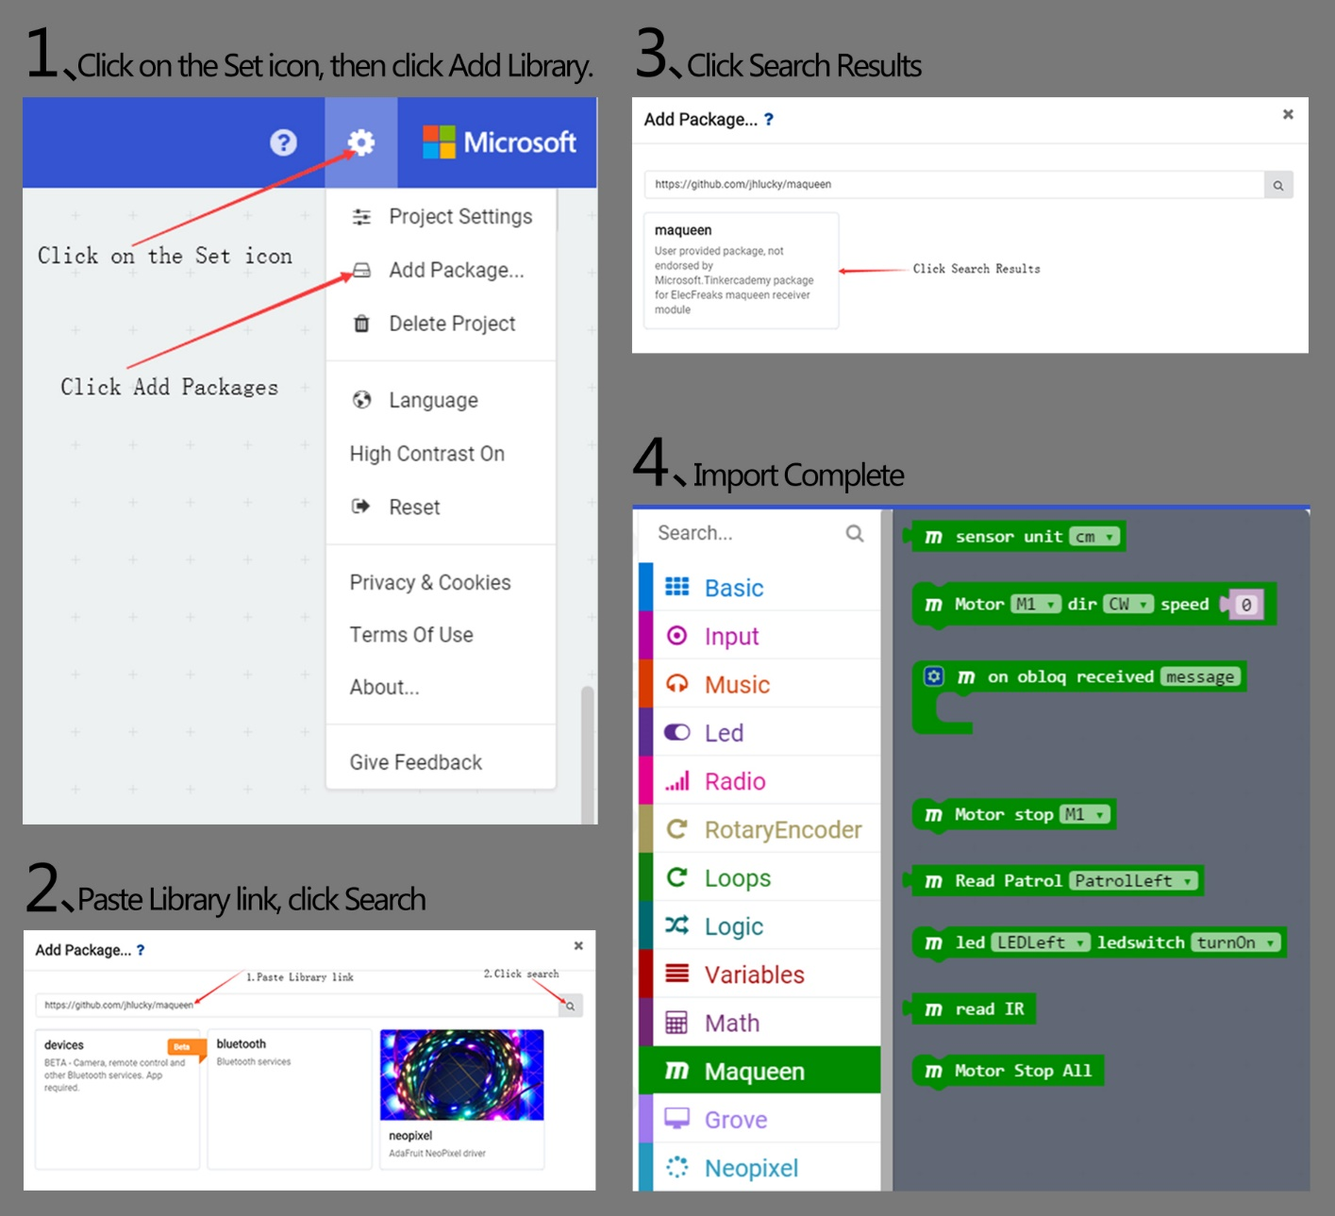

**Makecode Programming Example**

**Motor Control**

* Learning Target: Mastering the basic method of motor control.
* Effect: The car forward 1 second, right turn 1 second, left turn 1 second, back 1 second, back and right turn 1 second.



Makecode Program Link: <https://makecode.microbit.org/_2Cc9gM5P5aDs>

Screenshot of Makecode Graphical Program:

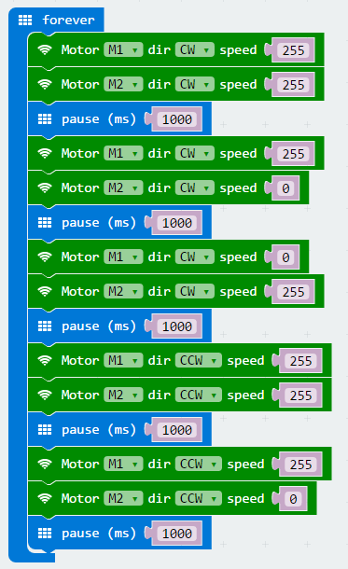

**RGB Breathing Ambient Light**

* Learning Target: Learn the basic way of using ambient light.
* Effect: The RGB ambient light at the bottom of the Maqueen shows a variety of colors and presents a gradient effect.



Makecode Program Link: <https://makecode.microbit.org/_WkgPLpAotP3f>

Screenshot of Makecode Graphical Program:

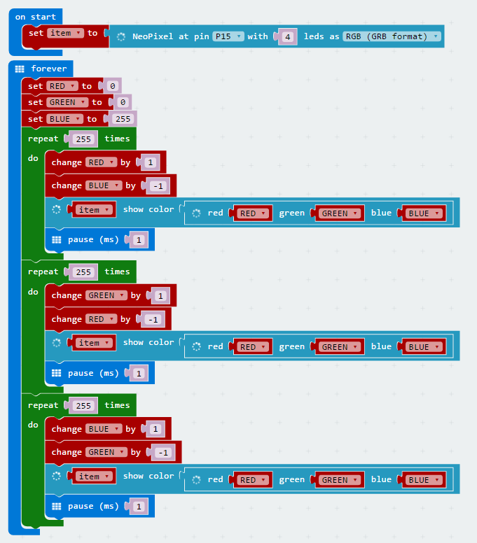

**LED Light Flash**

* Learning Target: Learn the using way of LED light and buzzer.
* Effect: The left and right LED lights flash alternately, and the buzzer emits two different tone frequencies at intervals of 500 milliseconds.



Makecode Program Link: <https://makecode.microbit.org/_6gKRm1RVsDxY>

Screenshot of Makecode Graphical Program:

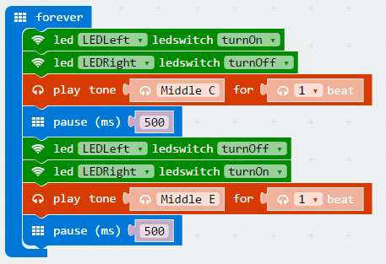

**Read Ultrasonic Distance**

* Learning Target: Learn to read the distance of ultrasound, so that later can be flexible use of these data.
* Effect: The ultrasonic detects the obstruction in front and the distance will be displayed on the dot-matrix screen in centimeters.



Makecode Program Link: <https://makecode.microbit.org/_4gi4Dj7yTWgK>

Screenshot of Makecode Graphical Program:

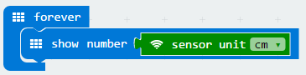

**Read Infrared Key Assignments**

* Learning Target: Learn to read the key assignments of infrared, so that later can be flexible use of these data.
* Effect: Put the the IR receiver toward the IR remote control, when you press any key on the IR remote control. The key assignments that corresponds to the pressed key will displayed on the dot matrix, in decimal notation the last two digits of the key assignments are displayed.



Makecode Program Link: <https://makecode.microbit.org/_361V7bbp0UAg>

Screenshot of Makecode Graphical Program:

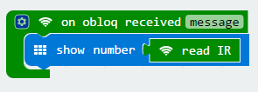

**IR Remote Control and Its Key Assignments** The key assignments in the following table are in hexadecimal. In this product, we read the last two digits of the key assignments and automatically convert them to decimal data.

|  |  |
| --- | --- |
| **Key** | **Key Assignments** |
| Power | 0xff00 |
| VOL | 0xfe01 |
| FUNC/STOP | 0xfd02 |
| Left | 0xfd04 |
| Pause | 0xfa05 |
| Right | 0xf906 |
| Down | 0xf708 |
| VOL- | 0xf609 |
| Up | 0xf50a |
| 0 | 0xf30c |
| EQ | 0xf20d |
| ST/REPT | 0xf10e |
| 1 | 0xef10 |
| 2 | 0xee11 |
| 3 | 0xfa05 |
| 4 | 0xeb14 |
| 5 | 0xea15 |
| 6 | 0xe916 |
| 7 | 0xe718 |
| 8 | 0xe619 |
| 9 | 0xe51a |
|  |  |

**IR Remote Control**

* Learning Target: Learn to use the IR remote control to command the car.
* Effect: Control car forward, left, right, back with 4 keys of IR remote control 2, 4, 6, 8.



Makecode Program Link: <https://makecode.microbit.org/_MfDXhX6MM35X>

Screenshot of Makecode Graphical Program:

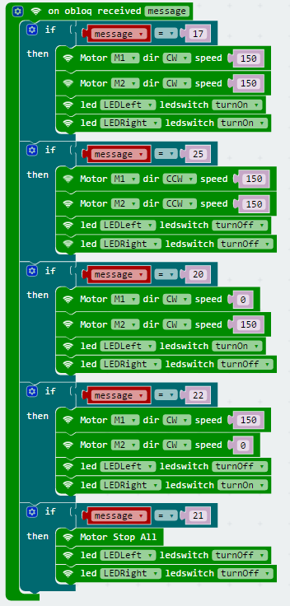

**Line-tracking**

* Effect: The car is running along the black line.



Makecode Program Link: <https://makecode.microbit.org/_1VzX7LLAC3im>

Screenshot of Makecode Graphical Program:

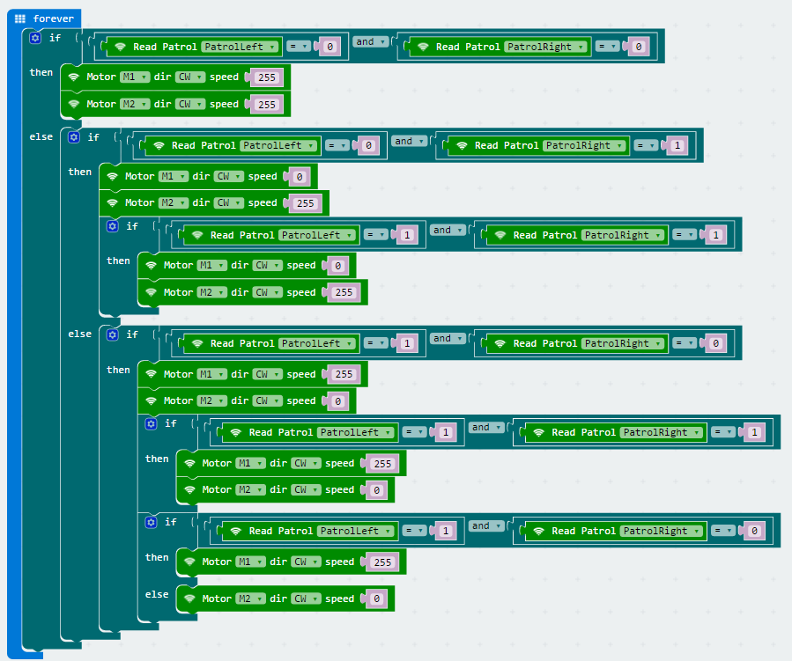

**Ultrasonic Obstacle-avoiding**

* Effect: Ultrasonic detects the distance between the car and the obstacle in front of it. If the distance is less than 35cm, the car will randomly choose to turn left or right to avoid obstacles.
* Fittings: SR04 Ultrasonic Module x 1 or SR04-P Ultrasonic Module x 1



Makecode Program Link: <https://makecode.microbit.org/_Fa4Ef3DwyXW7>

Screenshot of Makecode Graphical Program:

**Light-operated Sprite**

* Effect: The car does not move in the darker light, and as the flashlight illuminates the LED, the vehicle's forward speed begins to increase as the intensity of the light increases.



Makecode Program Link: <https://makecode.microbit.org/_fi6DWjCKeM9v>

Screenshot of Makecode Graphical Program:

